Table of Contents
- Executive Summary and Architectural Drivers
1.1 Executive Summary
1.2 Architectural Drivers
- Domain Decomposition
2.1 Bounded Contexts
2.2 Context Map
2.3 Organisational Alignment
- Architectural Nomination and Rationale
3.1 Nominated Architecture
3.2 Why Event-Driven Microservices?
3.3 Architectural Trade-off Analysis
- Data Management and Resilience
4.1 Data Management
4.2 Distributed Transactions
4.3 Fault Tolerance
4.4 Observability
- Fitness Functions and Operational Maturity
5.1 Performance Fitness Functions
5.2 Security Fitness Functions
5.3 Maintainability and Evolvability
5.4 CI/CD and Operational Maturity
- Development and Collaboration Evidence
6.1 Team Contribution Summary
6.2 Monday.com Evidence
6.3 GitHub Evidence
6.4 Team Communication Evidence
- AI-Assisted Design Portfolio
7.1 AI Design Tracking Table
7.2 Initial Prompt and Response
7.3 Progressive Prompt Refinements
7.4 Critical Evaluation
- Reference
- Appendixes

1. Executive Summary and Architectural Drivers

1.1 Executive Summary
EcoGrid Energy is developing a peer-to-peer renewable energy trading platform that allows households with solar panels to sell excess electricity to neighbouring consumers. The platform must support three distinct capabilities, matching buyers and sellers, continuously processing data from smart meters, and securely settling financial transactions.
This report proposes an Event-Driven Microservices Architecture. Marketplace, Smart Meter Integration and Financial Settlement are separated into independent services aligned with their business responsibilities. An event-streaming platform is used to handle high-frequency smart-meter data and enable asynchronous communication between services.
This design is selected because Smart Meter Integration has significantly different workload characteristics from Marketplace and Financial Settlement. Separating these domains allows ingestion workloads to scale independently while preventing large volumes of IoT data from directly affecting customer-facing trading operations.
Domain-Driven Design is used to establish clear bounded contexts and ownership. Resilience is provided through asynchronous messaging, idempotent processing, retries, dead-letter handling and service monitoring. Fitness functions are also proposed to continuously evaluate performance, security, maintainability and evolvability as the platform grows.

1.2 Architectural Drivers

S.No | Driver | EcoGrid Requirement | Architectural Response
1 | Scalability | Smart meters may generate continuous, high-frequency readings | Scale the Meter Ingestion service and event consumers independently.
2 | Performance | Meter data must be processed without delaying Marketplace requests | Separate synchronous Marketplace APIs from asynchronous meter-processing pipelines.
3 | Reliability | Temporary service failures should not result in lost meter or trade information. | Use durable messaging, retries, idempotent consumers and dead-letter handling.
4 | Security | Energy trades and financial information must be protected. | Authentication, authorization, encrypted communication and secure service boundaries.
5 | Maintainability | Marketplace, IoT and settlement logic evolve differently | Use independent bounded contexts and service ownership.
6 | Evolvability | New devices, pricing models or settlement methods may be introduced. | Event contracts and independently deployable services reduce change impact.
7 | Observability | Distributed workflows are more difficult to diagnose. | Centralised logging, metrics, traces and event-processing monitoring.

The architecture should therefore optimise not just for current functionality but for the maintainability and evolvability expected from a new system. The case specifically describes EcoGrid as an opportunity to design evolutionary architecture from the beginning.

2. Domain Decomposition

2.1 Bounded Contexts

S.No | Bounded Context | Responsibilities | Main Data
1 | Marketplace | Register energy offers, match buyers and sellers, determine trades and maintain trade status. | Offers, bids, trades, pricing information
2 | Smart Meter Integration | Receive meter readings, validate them and determine generation/consumption information. | Meter readings, device IDs, timestamps, energy measurements
3 | Financial Settlement | Calculate settlement amounts, process financial transactions and maintain settlement records. | Transactions, settlement status, payment references

The separation prevents a single shared domain model from being used for unrelated purposes. A Marketplace trade does not need to contain all raw IoT measurements, while the Meter Integration service should not contain payment logic.

2.2 Context Map
A suitable high-level interaction is:
Smart Meters
|
v
Smart Meter Integration
|
| MeterReadingReceived /
| EnergyAvailabilityUpdated
v
Event Bus
|
v
Marketplace Service
|
| TradeMatched
v
Event Bus
|
v
Financial Settlement
|
| SettlementCompleted
v
Marketplace / Notification

The Smart Meter Integration context acts as the producer of validated energy information. Marketplace consumes relevant events and performs buyer-seller matching. When a trade is confirmed, Marketplace publishes a TradeMatched event. Financial Settlement consumes this event and handles the corresponding payment process.
This design prevents high-frequency meter traffic from creating direct synchronous dependencies between the three domains.

2.3 Organisational Alignment
As the case describes a founding team of four, complete organisational separation into three large teams would be unrealistic.

S.No | Area | Primary Ownership | Shared Responsibility
1 | Marketplace | Developer 1 | API contracts and testing
2 | Smart Meter Integration | Developer 2 | Kafka/event infrastructure
3 | Financial Settlement | Developer 3 | Security and transaction integrity
4 | Platform/Integration | Developer 4 | CI/CD, observability and infrastructure
5 | Architecture | Whole Team | ADRs, domain boundaries and event contracts
Primary ownership gives accountability while maintaining collaboration across a small founding team.

3. Architectural Nomination and Rationale

3.1 Nominated Architecture
The nominated solution is an Event-Driven Microservices Architecture.
Three primary services are proposed:
- Marketplace Service
- Smart Meter Integration Service
- Financial Settlement Service
A message-streaming platform such as Apache Kafka can provide asynchronous event exchange, while synchronous APIs can be retained for operations where an immediate response is necessary.
Python can be used for service implementation, satisfying the required programming-language component.GitHub, a communication platform and Monday.com or equivalent are also explicitly required.
3.2 Why Event-Driven Microservices?
The key architectural issue is that smart-meter ingestion and Marketplace requests have different workload profiles.
Smart meters generate continuous streams of data. Processing every reading through direct synchronous calls to Marketplace would tightly couple the two domains and potentially allow an ingestion spike to affect customer trading functionality.
Instead:
Meter → Event Stream → Consumers
allows incoming readings to be buffered and processed asynchronously.
Marketplace can therefore consume only the information required for trading instead of processing every raw meter operation directly.
Microservices further allow Smart Meter Integration to scale independently from Financial Settlement and Marketplace.

3.3 Trade-off Analysis

S.No | Architecture | Strengths | Weaknesses | Suitability
1 | Monolith | Simple development and deployment; low operational overhead. | Difficult to scale IoT processing independently; stronger coupling between domains. | Low-medium
2 | Microservices | Independent scaling, deployment and ownership. | Network failures, distributed data and operational complexity. | High
3 | Event-Driven Architecture | Excellent for high-volume asynchronous IoT processing and loose coupling. | Eventual consistency and harder debugging. | High
4 | Event-Driven Microservices | Combines service independence with scalable asynchronous processing. | Highest operational complexity and requires strong monitoring. | Selected

The additional complexity is considered acceptable because the central requirement of EcoGrid is the separation of high-frequency IoT processing from business transactions.
However, services should correspond to meaningful domain boundaries rather than creating unnecessarily small microservices

4. Data Management and Resilience
4.1 Data Management
Each service should own data relevant to its bounded context.

S.No | Service | Suggested Data Responsibility
1 | Meter Integration | Meter readings and device state
2 | Marketplace | Buyers, sellers, offers and trades
3 | Financial Settlement | Settlement and payment records
Direct access to another service's database should be avoided. Services exchange required information through APIs or domain events.
This reduces database-level coupling and allows each domain to evolve independently.

4.2 Distributed Transactions
A single database transaction cannot safely span independent services

Trade Matched
↓
Settlement Requested
↓
Payment Processed
↓
Settlement Completed

A Saga-style workflow can be used instead of a global distributed transaction.
Example:
- Marketplace creates a confirmed trade.
- TradeMatched is published.
- Financial Settlement receives the event.
- Settlement attempts payment.
- SettlementCompleted or SettlementFailed is published.
- Marketplace updates trade status accordingly.
If settlement fails, compensating behaviour can return the trade to an appropriate state rather than attempting to roll back databases across services.
Consumers should also be idempotent, ensuring that repeated delivery of the same event does not result in duplicate payments or settlements.

4.3 Fault Tolerance
S.No | Failure | Resilience Strategy
1 | Temporary network failure | Retry with controlled backoff
2 | Slow downstream service | Timeout
3 | Repeated event failure | Dead-letter queue
4 | Duplicate message | Idempotency key
5 | Service unavailable | Event buffering and later processing
6 | Invalid meter reading | Validation and rejected-event handling
7 | Settlement failure | Compensating transaction
8 | Service overload | Horizontal scaling and back-pressure
The objective is to allow individual components to experience failures without causing the entire EcoGrid platform to stop operating.

4.4 Observability
Event-driven systems require strong observability because one business transaction may pass through several services.
The platform should capture:
S.No | Observability Area | Purpose
1 | Logs | Record important service and processing events
2 | Metrics | Monitor throughput, latency and failures
3 | Distributed Tracing | Follow a trade across multiple services
4 | Event Lag | Identify delayed Kafka consumers
5 | Error Rate | Detect unhealthy services
6 | Alerts | Notify the team when thresholds are breached
A shared correlation or trace ID should follow important workflows so developers can trace a trade from meter information through Marketplace and Settlement.
5. Fitness Functions and Operational Maturity
Fitness functions provide measurable checks that determine whether the architecture continues to meet its desired characteristics as the system evolves.
These are proposed targets for your design, so your group should validate or adjust the numerical values.

S.No | Quality Attribute | Proposed Fitness Function | Example Target
1 | Performance | Measure Marketplace API latency | 95% of requests < 300 ms
2 | IoT Performance | Measure meter event processing delay | 95% processed within 2 sec
3 | Availability | Monitor Marketplace availability | ≥ 99.9%
4 | Reliability | Detect lost validated meter events | 0 acknowledged events lost
5 | Security | Automated dependency/security scan | 0 unresolved critical vulnerabilities
6 | Maintainability | Enforce domain dependency rules | No forbidden cross-context dependencies
7 | Evolvability | Validate event schema compatibility | No breaking event changes without versioning
8 | Settlement Integrity | Reconcile successful trades and settlements | 100% reconciliation
9 | Deployability | Automated CI/CD validation | All tests pass before deployment
10 | Observability | Verify tracing across critical flows | All trade workflows carry trace IDs

Fitness functions should be implemented where possible in CI/CD pipelines and monitoring rather than being treated only as documentation.
For example, a build should fail if Marketplace directly imports internal Meter Integration code or if an event schema introduces an incompatible change.
6. Development and Contributions

6.1 Contribution Summary

S.No | Team Member | Responsibilities | Evidence
1 | Member 1 | Worked on Executive Summary, Architectural Drivers,Marketplace domain design, and Domain Decomposition. Helped identify scalability, performance, security, maintainability and evolvability requirements. Contributed to defining the Marketplace bounded context and its responsibilities
2 | Konda lashya sri | Worked on Smart Meter Integration, Context Map and Organisational Alignment. Defined how high-frequency IoT data enters the system and how Smart Meter Integration communicates with Marketplace through events. Helped design service ownership and event flows. | 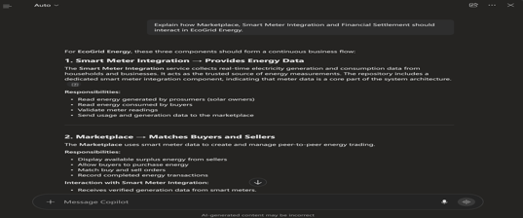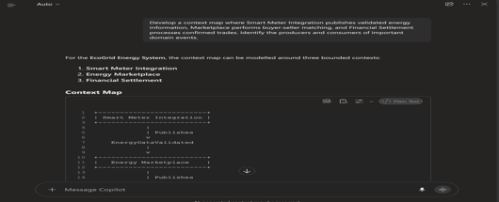  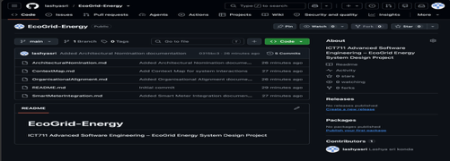
3 | Dugyala umesh | Worked on Architectural Nomination, Event-Driven Microservices rationale, Trade-off Analysis and Financial Settlement design. Compared Monolith, Microservices and Event-Driven Architecture and helped justify the selected architecture. | 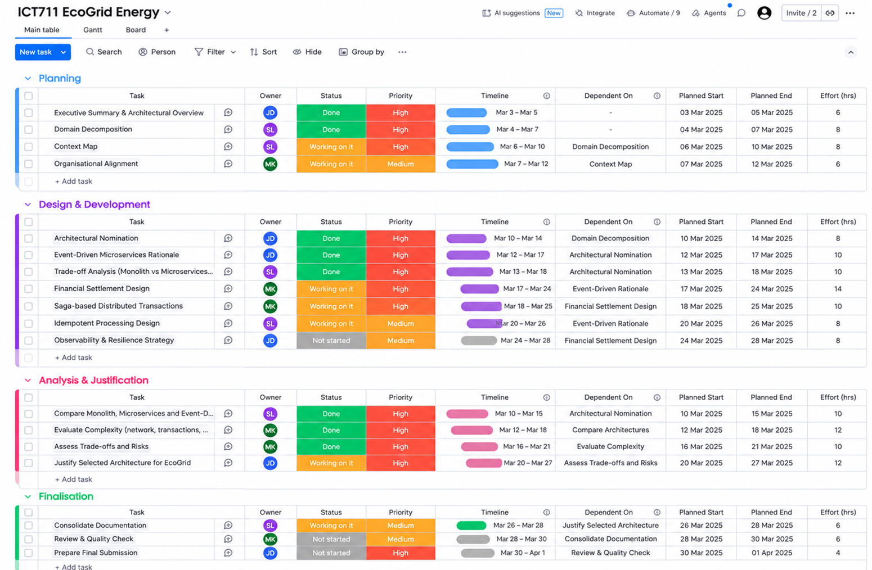
4 | Member 4 | Worked on Data Management, Distributed Transactions, Fault Tolerance, Observability, Fitness Functions and CI/CD/Operational Maturity. Designed Saga-based settlement flow, resilience mechanisms, monitoring strategy and automated architectural check

7. AI-Assisted Design Portfolio

AI Table 1 Architectural Drivers

Member 1

S.No | Stage | Actual Prompt | AI Response Summary | Accepted | Modified | Rejected | Reason
1 | Initial Attempt | Analyse the EcoGrid Energy case study and identify the main architectural drivers for a peer-to-peer renewable energy trading platform involving Marketplace, Smart Meter Integration and Financial Settlement. | Complete after running prompt |  | yes |  | Complete after evaluation
2 | Refinement 1 | Refine the architectural drivers specifically for EcoGrid. Focus on scalability, performance, reliability, security, maintainability, evolvability and observability. Explain why each driver matters to EcoGrid rather than providing generic definitions. | Complete after running prompt |  | yes |  | Complete after evaluation
3 | Refinement 2 | Prioritise the architectural drivers considering that Smart Meter Integration processes continuous high-frequency IoT data while Marketplace and Financial Settlement have different workload and consistency requirements. Explain any trade-offs between the drivers. | Complete after running prompt | yes |  |  | Complete after evaluation
4 | Refinement 3 | Produce a concise final architectural-driver analysis for EcoGrid. Map each driver to the specific EcoGrid problem it addresses and an appropriate architectural response for an Event-Driven Microservices Architecture. | Complete after running prompt | yes |  |  | Complete after evaluation

Progression: generic drivers → EcoGrid-specific drivers → prioritisation/trade-offs → final architectural mapping.

AI Table 2 Domain Decomposition
Member 1

S.No | Stage | Actual Prompt | AI Response Summary | Accepted | Modified | Rejected | Reason
1 | Initial Attempt | Apply Domain-Driven Design to EcoGrid Energy and identify suitable business domains and bounded contexts. | Complete after running prompt |  | yes |  | Complete after evaluation
2 | Refinement 1 | Define separate bounded contexts for Marketplace, Smart Meter Integration and Financial Settlement. Describe the responsibilities and data owned by each context | Complete after running prompt |  | yes |  | Complete after evaluation
3 | Refinement 2 | Refine the bounded contexts so that raw smart-meter information, marketplace trading logic and financial-settlement logic are not unnecessarily shared. Explain what belongs and does not belong inside each context. | Complete after running prompt | yes |  |  | Complete after evaluation
4 | Refinement 3 | Produce the final EcoGrid domain decomposition showing the responsibility, data ownership and boundaries of Marketplace, Smart Meter Integration and Financial Settlement. Explain how these boundaries improve maintainability and independent evolution | Complete after running prompt | yes |  |  | Complete after evaluation

AI Table 3 Context Map

Konda lashya sri

S.No | Stage | Actual Prompt | AI Response Summary | Accepted | Modified | Rejected | Reason
1 | Initial Attempt | Explain how Marketplace, Smart Meter Integration and Financial Settlement should interact in EcoGrid Energy. | Complete after running prompt |  | yes |  | Complete after evaluation
2 | Refinement 1 | Identify which interactions between the EcoGrid bounded contexts should use synchronous APIs and which should use asynchronous events, considering the high-frequency nature of smart-meter data. | Complete after running prompt |  | yes |  | Complete after evaluation
3 | Refinement 2 | Develop a context map where Smart Meter Integration publishes validated energy information, Marketplace performs buyer-seller matching, and Financial Settlement processes confirmed trades. Identify the producers and consumers of important domain events. | Complete after running prompt | yes |  |  | Complete after evaluation
4 | Refinement 3 | Produce a final EcoGrid context map that minimises direct coupling. Include events such as EnergyAvailabilityUpdated, TradeMatched, SettlementCompleted and SettlementFailed, while retaining synchronous APIs where an immediate response is necessary | Complete after running prompt | yes |  |  | Complete after evaluation

AI Table 4 Architectural Nomination
Konda lashya sri

S.No | Stage | Actual Prompt | AI Response Summary | Accepted | Modified | Rejected | Reason
1 | Initial Attempt | Recommend a suitable software architecture for EcoGrid Energy considering Marketplace, high-frequency Smart Meter Integration and Financial Settlement. | Complete after running prompt |  | yes |  | Complete after evaluation
2 | Refinement 1 | Evaluate Microservices and Event-Driven Architecture for EcoGrid. Explain how each approach handles high-frequency IoT data, independent scaling, maintainability and fault isolation. | Complete after running prompt |  | yes |  | Complete after evaluation
3 | Refinement 2 | Analyse Event-Driven Microservices as a combined architecture for EcoGrid. Discuss independent scaling, loose coupling, fault isolation, eventual consistency, network failures, distributed-data management and operational complexity. | Complete after running prompt | yes |  |  | Complete after evaluation
4 | Refinement 3 | Produce a final architectural recommendation for EcoGrid. Justify Event-Driven Microservices while limiting decomposition to meaningful business-aligned services for Marketplace, Smart Meter Integration and Financial Settlement. | Complete after running prompt | yes |  |  | Complete after evaluation

AI Table 5 Architectural Trade-off Analysis

UMESH
S.No | Stage | Actual Prompt | AI Response Summary | Accepted | Modified | Rejected | Reason
1 | Initial Attempt | Compare Monolithic Architecture, Microservices and Event-Driven Architecture for the EcoGrid Energy platform. | Compared the three architectures based on structure, scalability, maintenance, reliability, development complexity, real-time processing and suitability for EcoGrid. It suggested Microservices combined with Event-Driven Architecture as the strongest option. |  | Yes |  | The response provided a useful basic comparison, but more detailed technical evaluation was required before making the final architecture decision.
2 | Refinement 1 | Compare Monolithic Architecture, Microservices and Event-Driven Architecture for EcoGrid using scalability, performance, fault isolation, maintainability, deployment complexity and operational overhead. | Compared the architectural approaches using scalability, performance, fault isolation, maintainability, deployment complexity and operational overhead for EcoGrid. |  | Yes |  | The comparison became more technical and relevant, but it still needed deeper analysis of the additional complexity created by distributed architectures.
3 | Refinement 2 | Extend the comparison by analysing the complexity tax introduced by each approach. Consider network failures, distributed transactions, eventual consistency, monitoring, deployment infrastructure and team capability. | Analysed the additional complexity of each architecture, including network failures, distributed transactions, eventual consistency, monitoring requirements, deployment infrastructure and required team skills. | Yes |  |  | This response was accepted because it clearly explained both the benefits and operational costs of each architectural option.
4 | Refinement 3 | Produce a final trade-off evaluation comparing Monolith, Microservices, | Produced a final trade-off analysis and identified Event-Driven Microservices |  |  |  | The final response provided a balanced justification instead of choosing an architecture only because of scalability.
 |  |  |  | Yes
4 | Refinement 3 | Event-Driven Architecture and Event-Driven Microservices. Justify which architecture provides the most appropriate balance for EcoGrid rather than simply selecting the most scalable option. | as the most balanced approach for EcoGrid, considering scalability, maintainability, resilience, complexity and real-time energy processing requirements.

AI Table 6 Resilience Design

UMESH DUGYALA

S.No | Stage | Actual Prompt | AI Response Summary | Accepted | Modified | Rejected | Reason
1 | Initial Attempt | Identify the major failure scenarios that could occur in EcoGrid's Event-Driven Microservices Architecture and recommend resilience techniques. | Identified common failures such as service outages, network problems, duplicate events and processing failures, and suggested resilience techniques such as retries, timeouts and dead-letter queues. |  | Yes |  | The initial response identified useful resilience concepts, but it was too general and needed to be more specific to EcoGrid.
2 | Refinement 1 | Analyse EcoGrid-specific failures including temporary network errors, unavailable services, duplicate events, invalid smart-meter readings, repeated event failures, service overload and settlement failures. | Analysed EcoGrid-specific failure scenarios including temporary network errors, unavailable services, duplicate events, invalid meter readings, repeated event failures, overload and settlement failures. |  | Yes |  | The response was more relevant to EcoGrid, but it still needed clear mapping between each failure and the most appropriate resilience technique.
3 | Refinement 2 | Evaluate retries with controlled backoff, timeouts, idempotency, dead-letter queues, event buffering, back-pressure and compensating transactions for the identified EcoGrid failure scenarios. | Evaluated retries with backoff, timeouts, idempotency, dead-letter queues, event buffering, back-pressure and compensating transactions and explained where each technique should be used. | Yes |  |  | This response was accepted because it connected specific resilience techniques with the identified EcoGrid failure scenarios.
4 | Refinement 3 | Produce a final EcoGrid resilience strategy mapping each important failure mode to an appropriate mitigation. Include Saga-based distributed transactions, idempotent processing, observability and relevant trade-offs. | Produced a final resilience strategy mapping failures to mitigations and included Saga-based transactions, idempotent event processing, monitoring and observability, together with the main trade-offs. | Yes |  |  | The final response provided a complete and practical resilience strategy suitable for EcoGrid's Event-Driven Microservices Architecture.

Critical Evaluation

The initial AI-assisted analysis identified Event-Driven Microservices as a suitable architecture because Smart Meter Integration has different scalability and performance requirements from Marketplace and Financial Settlement. However, the recommendation was not accepted without modification. The group reviewed the complexity introduced by distributed communication, eventual consistency, service coordination, independent data ownership and monitoring before confirming the final approach.
The design was refined to retain only three business-aligned services: Marketplace, Smart Meter Integration and Financial Settlement. Excessive service decomposition was rejected because it would create unnecessary deployment and operational overhead for a four-person team. The group also avoided using asynchronous communication for every interaction. Event-driven communication was selected mainly for high-frequency meter processing and cross-domain events, while synchronous APIs were retained where an immediate response is required. Resilience recommendations such as retries, idempotency, dead-letter queues and compensating transactions were accepted after validation. Fitness-function thresholds were treated as proposed targets rather than guaranteed values. Overall, AI was used to support exploration, while the final design was validated through trade-off analysis, Domain-Driven Design and consideration of the team’s practical capabilities.

8. References

[1] Victorian Institute of Technology, “ICT711 Advanced Software Engineering,” course materials, 2026.

[2] E. Evans, Domain-Driven Design: Tackling Complexity in the Heart of Software. Boston, MA, USA: Addison-Wesley, 2003.
[3] S. Newman, Building Microservices: Designing Fine-Grained Systems, 2nd ed. Sebastopol, CA, USA: O’Reilly Media, 2021.
[4] C. Richardson, Microservices Patterns: With Examples in Java. Shelter Island, NY, USA: Manning Publications, 2018.
[5] M. Kleppmann, Designing Data-Intensive Applications. Sebastopol, CA, USA: O’Reilly Media, 2017.

Appendix A Collaboration Evidence

A.1 Monday.com

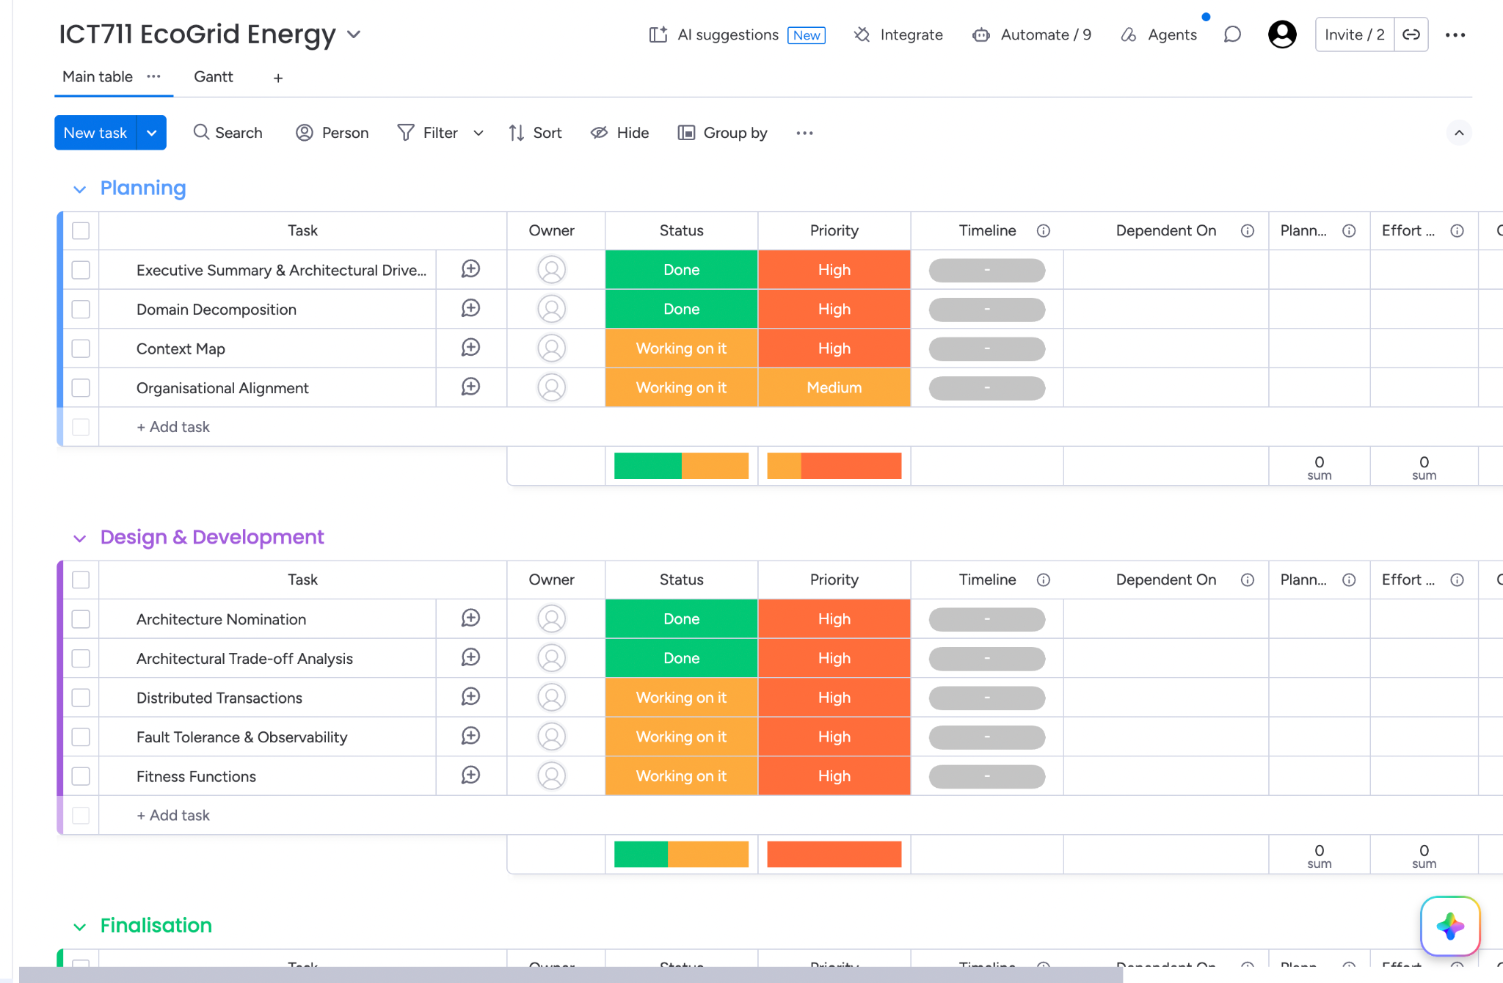

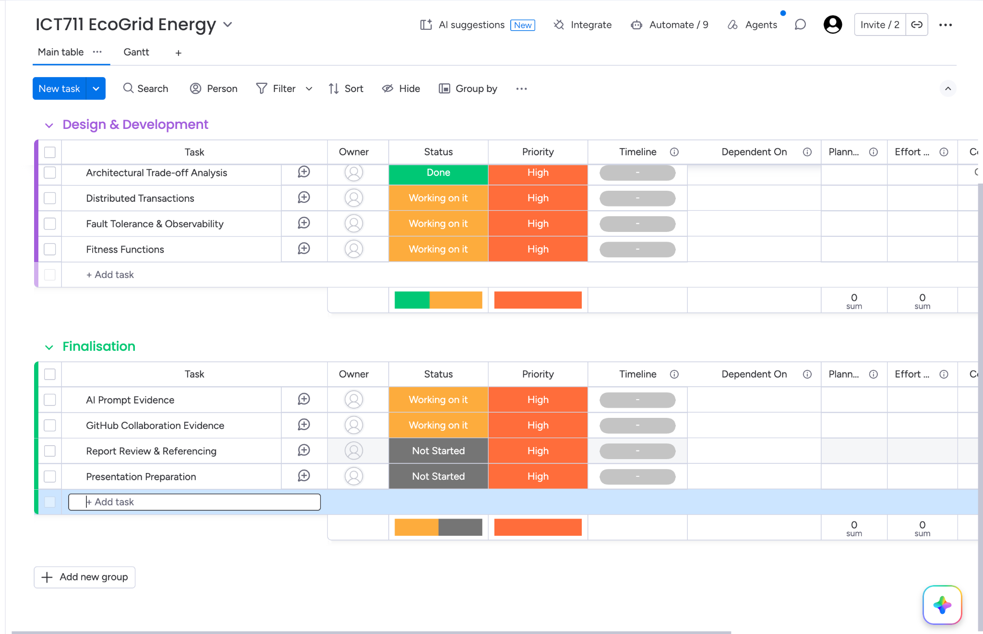

A.2 GitHub

A.3 Teams
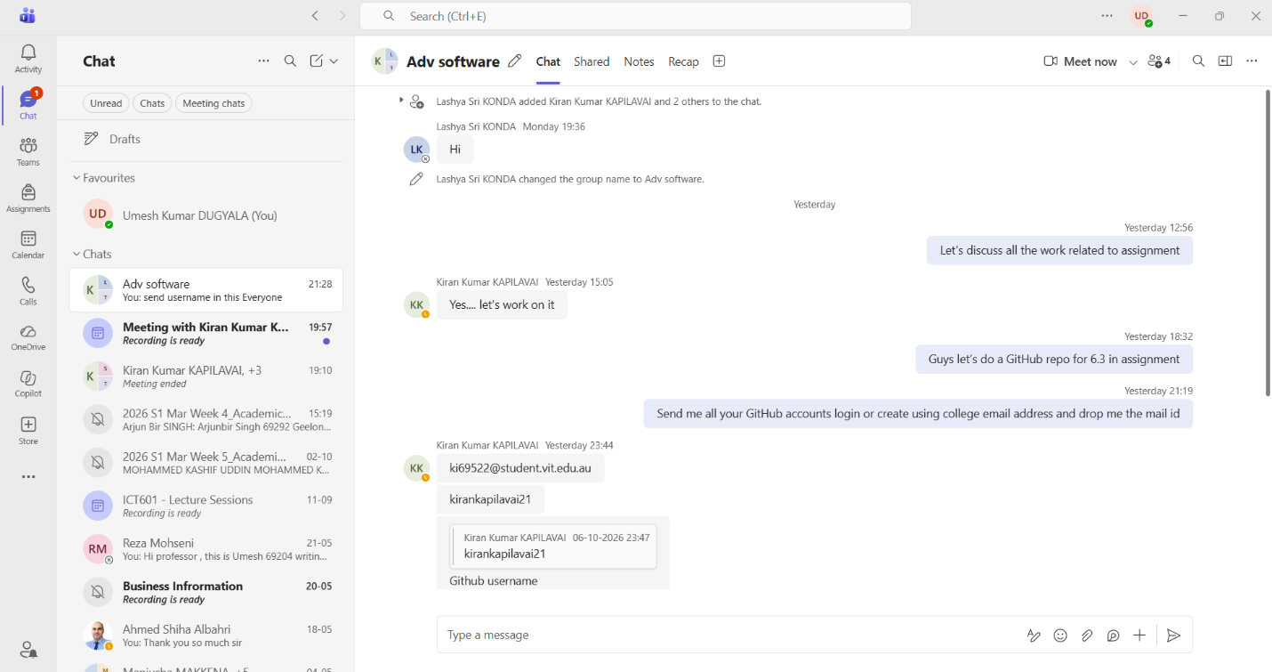


Appendix B AI Conversation Screenshots

UMESH
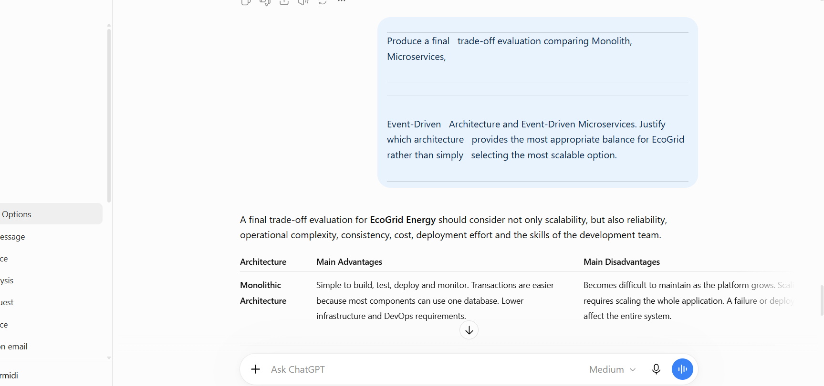
UMESH
